**Week 1**

11-03-2024

<https://www.tutorialspoint.com/antenna_theory/antenna_theory_fundamentals.htm>

antenna-theory.com

------------------------------------------------------------------------------

Things to live by-

A charged particle produces an electric field. This electric field exerts a force on other charged particles. Positive charges accelerate in the direction of the field and negative charges accelerate in a direction opposite to the direction of the field.

A moving charged particle produces a magnetic field. This magnetic field exerts a force on other moving charges. The force on these charges is always perpendicular to the direction of their velocity and therefore only changes the direction of the velocity, not the speed.

An accelerating charged particle produces an electromagnetic (EM) wave. Electromagnetic waves are electric and magnetic fields traveling through empty space with the speed of light c. A charged particle oscillating about an equilibrium position is an accelerating charged particle. If its frequency of oscillation is f, then it produces an electromagnetic wave with frequency f. The wavelength λ of this wave is given by λ = c/f. Electromagnetic waves transport energy through space. This energy can be delivered to charged particles a large distance away from the source.

Why simulation?

[Is This The Best Antenna Design And Simulation Software? | Markus Laudien](https://www.youtube.com/watch?v=81nfAqboFE4) - Talks about why antenna simulation is important…antennas are part of a bigger system consisting of many types of materials, many other electronic components etc… for example, in IOT applications if we are to integrate an antenna into a coffee machine, the machine has water, milk, glass, aluminium etc. If it has a serial monitor and a PCB then the radiations from the antenna interferes with those as well… both while receiving and transmitting due to reciprocity of directional patterns…based on all this it is the responsibility of the engineer to pick the best possible antenna design and placement location to be able to use the antenna radiations effectively… this would take multiple iterations to do which is a waste of money, time and manpower so engineers have fallen back on computer software to do the heavy lifting and be able to generate the radiation patterns and other such important information as it would appear if built in real life. So it is of huge help… You can also see how much radiation is coming out..maybe for wearable tech like smart watches or bluetooth headphones it is necessary to know how much radiation we are taking due to health concerns..

Using all this knowledge the engineer can make informed decisions as to whether to buy the antenna from the market or make one on his own..if he were to make one what are the dimensions for correct impedance matching etc.

Most of these softwares allow you to import your product design from some cad softwares, assign which part is made of what material and from there it is practically plug and play..

<https://www.3ds.com/products-services/simulia/products/electromagnetic-simulation/antenna-design-and-simulation/> -

Simulation can help us simulate antenna arrays as well as help us with high impedance matching, considering thermal effects , platform effects(characteristics of the platform on which the antenna is placed - whether it absorbs radiation, reflects etc.) , helps for certifications for use by people..

Basic antennas

The sole functionality of an antenna is power radiation or reception.

The functioning of an antenna depends upon the radiation mechanism of a transmission line.

A conductor, which is designed to carry current over large distances with minimum losses, is termed as a transmission line.

If the power has to be radiated, though the current conduction is with uniform velocity, the wire or transmission line should be bent, truncated or terminated. If this transmission line has current, which accelerates or decelerates with a time varying constant, then it radiates the power even though the wire is straight.

The device or tube, if bent or terminated to radiate energy, then it is called a waveguide. These are especially used for the microwave transmission or reception.

Radiation pattern

Basically, the radiation pattern is a plot that tells us where the antenna transmits and receives.

An isotropic antenna is one which radiates power equally in all directions..it is impossible to make in practice but is the ideal antenna compared to which we study real antennas. The radiation pattern of an isotropic antenna is toroidal… Some antennas are called omni directional which means that they are isotropic in one plane , for example, dipole antennas.

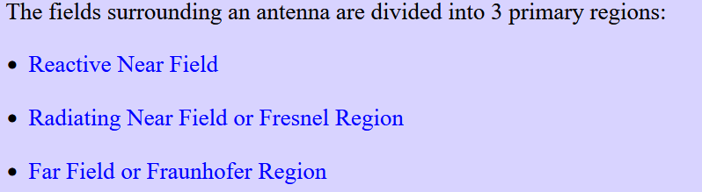

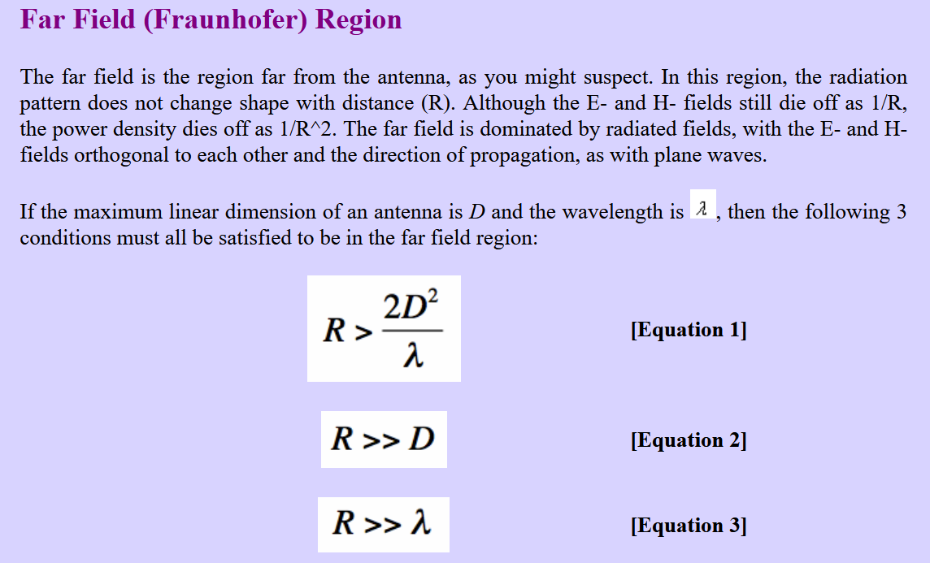

Near a radiating antenna, there are reactive fields (see reactive near field region, below), that typically have the [E-fields](http://www.antenna-theory.com/definitions/efield.php) and [H-fields](http://www.antenna-theory.com/definitions/hfield.php) die off with distance as 1/R and 1/R. The third equation above ensures that these near fields are gone, and we are left with the radiating fields, which fall off with distance as 1/R.

The far-field region is sometimes referred to as the Fraunhofer region, a carryover term from optics.

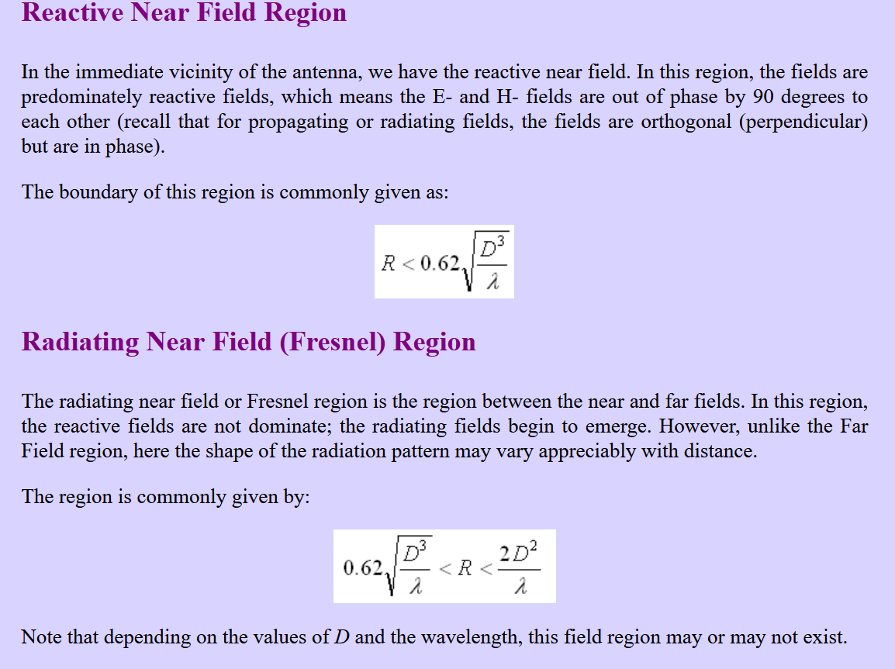

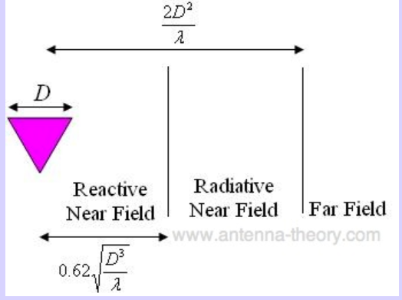

**Directivity** is a fundamental antenna parameter. It is a measure of how 'directional' an antenna's radiation pattern is. An antenna that radiates equally in all directions would have effectively zero directionality, and the directivity of this type of antenna would be 1 (or 0 dB).

Antennas for cell phones should have a low directivity because the signal can come from any direction, and the antenna should pick it up. In contrast, satellite dish antennas have a very high directivity, because they are to receive signals from a fixed direction. As an example, if you get a directTV dish, they will tell you where to point it such that the antenna will receive the signal.

A directivity of 2.5 means the antenna receives 2.5 times the power an isotropic antenna would receive in that particular direction.

The **main beam** is the region around the direction of maximum radiation (usually the region that is within 3 dB of the peak of the main beam). The **sidelobes** are smaller beams that are away from the main beam. These sidelobes are usually radiation in undesired directions which can never be completely eliminated.

The angular separation, in which the magnitude of the radiation pattern decreases by 50% (or -3dB) from the peak of the main beam, is the **Half Power Beam Width.(HPBW)**

The angular span between the first pattern nulls adjacent to the main lobe, is called the **First Null Beam Width.(FNBW)**

FNBW=2*HPBW

The **Sidelobe Level** is another important parameter used to characterize radiation patterns. The sidelobe level is the maximum value of the sidelobes (away from the main beam)

Impedance matching

**Impedance** relates the voltage and current at the input to the antenna. The real part of the antenna impedance represents power that is either radiated away or absorbed within the antenna. The imaginary part of the impedance represents power that is stored in the near field of the antenna. This is non-radiated power. An antenna with a real input impedance (zero imaginary part) is said to be resonant. Note that the impedance of an antenna will vary with frequency.

The approximate value of impedance of a transmitter, when equals the approximate value of the impedance of a receiver, or vice versa, is called **Impedance matching**. Impedance matching is necessary between the antenna and the circuitry. The impedance of the antenna, the transmission line, and the circuitry **should match so that maximum power transfer takes place between the antenna and the receiver or the transmitter.**

The power radiated by an antenna, will be effectively radiated, if the antenna impedance matches the free space impedance. For a receiver antenna, the antenna's output impedance should match with the input impedance of the receiver amplifier circuit. For a transmitter antenna, the antenna's input impedance should match with the transmitter amplifier’s output impedance, along with the transmission line impedance.

The term, which indicates the impedance mismatch is **VSWR**. VSWR stands for **Voltage Standing Wave Ratio**. It is also called SWR. The higher the impedance mismatch, the higher will be the value of VSWR. The ideal value of VSWR should be 1:1 for effective radiation. A VSWR of 6 or more is pretty high and will generally need to be improved. If the antenna is matched to the transmission line (ZA=ZO), then the input impedance does not depend on the length of the transmission line.

**VSWR = (1+|Γ|)/(1-|Γ|) where the T sort of thing is equal to ZL-ZO/ZL+ZO with**

**ZL = impedance of antenna**

**ZO = impedance of transmission line**

Reflected power is the power wasted out of the forward power. Both reflected power and VSWR indicate the same thing.

<https://www.youtube.com/watch?v=iVNDFfNGqQA>

<https://www.youtube.com/watch?v=mEvoY5zU0WM>

<https://www.youtube.com/watch?v=jgjaFzsYd88>

S-parameters

* SNM represents the power transferred from Port M to Port N in a multi-port network. A port can be loosely defined as any place where we can deliver voltage and current. So, if we have a communication system with two radios (radio 1 and radio 2), then the radio terminals (which deliver power to the two antennas) would be the two ports.
* S11 then would be the reflected power radio 1 is trying to deliver to antenna 1.
* S22 would be the reflected power radio 2 is attempting to deliver to antenna 2.
* S12 is the power from radio 2 that is delivered through antenna 1 to radio 1.
* Note that in general S-parameters are a function of frequency (i.e. vary with frequency). S21=0 dB implies that all the power delivered to antenna 1 ends up at the terminals of antenna 2. If S21=-10 dB, then if 1 Watt (or 0 dB) is delivered to antenna 1, then -10 dB (0.1 Watts) of power is received at antenna 2.
* If an amplifier exists in the circuitry, then S21 can show gain (i.e. S21 > 0 dB). This means that for 1 W of power delivered to Port 1, more than 1 W of power is received at Port 2.
* S11 represents how much power is reflected from the antenna, and hence is known as the **reflection coefficient** (sometimes written as gamma) or **return loss**.
* S11 vs frequency is usually by something called a vector network analyzer(VNA).

Bandwidth and related terms

The most basic definition of bandwidth is a range of frequency…or the difference between maximum and minimum frequency for some parameter to work in some way..Let's say some antenna is circularly polarized for the frequency ranges 1.1-1.3 GHz. so this 0.2 GHz is the bandwidth in which it is circularly polarized.

The particular frequency within a frequency band, at which the signal strength is maximum, is called resonant **frequency**. It is also called the **center frequency (fC)** of the band.

The ratio of absolute bandwidth to the center frequency of that bandwidth can be termed as **percentage bandwidth (or fractional bandwidth when quoted as a ratio).**

**Antenna Q -** 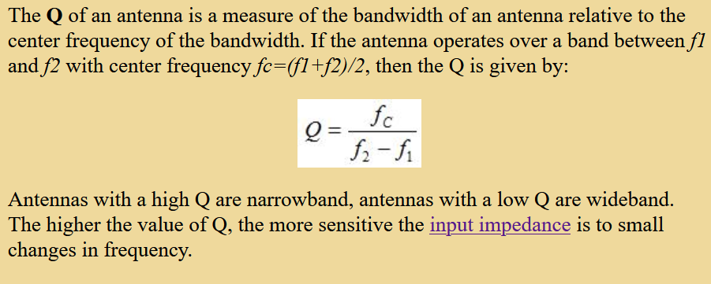

**Radiation intensity** is defined as the power per unit solid angle.

U=r2×Wrad

where U is the radiation intensity

r is the radial distance

Wrad is the power radiated.

The ratio of maximum radiation intensity of the subject antenna to the radiation intensity of an isotropic or reference antenna, radiating the same total power is called the directivity.

**Aperture efficiency** of an antenna is the ratio of the effective radiating area (or effective area) to the physical area of the aperture. εA=Aeff/Ap

**Antenna Efficiency** is the ratio of the radiated power of the antenna to the input power accepted by the antenna.

Antenna Gain

The term antenna gain describes how much power is transmitted in the direction of peak radiation to that of an isotropic source.

Gain is usually measured in dB.

Unlike directivity, antenna gain takes the losses that occur also into account and hence focuses on the efficiency so it is found on data sheets more often.

G=ηeD

Where G is gain of the antenna.

ηe is the antenna’s efficiency.

D is the directivity of the antenna.

If the antennas used in radar systems produce side lobes, target tracing becomes very difficult. This is because false targets are indicated by these side lobes. It is messy to trace out the real ones and to identify the fake ones. Hence, elimination of these side lobes is a must, in order to improve the performance and save energy. If you know exactly where your desired signal is coming from, you would like to have maximum gain (towards the desired) direction. However, if you don't know where the desired signal will be coming from, it is better to have a low gain antenna.

Electrically small antennas (small relative to the wavelength of the frequency that the antenna operates at) can be very inefficient, with antenna gains lower than -10 dB (even without accounting for impedance mismatch loss).

dB - decibels, as we have been discussing. 10 dB means 10 times the energy relative to an isotropic antenna in the peak direction of radiation.

dBi - "decibels relative to an isotropic antenna". This is the same as dB as we have been using it. 3 dBi means twice (2x) the power relative to an isotropic antenna in the peak direction.

dBd - “decibels relative to adipole antenna.” Note that a half-wavelength dipole antenna has a gain of 2.15 dBi. Hence, 7.85 dBd means the peak gain is 7.85 dB higher than a dipole antenna; this is 10 dB higher than an isotropic antenna.

EIRP

The amount of power that an isotropic antenna radiates to produce the peak power density observed in the direction of maximum antenna gain, is called as Equivalent Isotropic Radiated Power.

Beam area is the solid angle through which all the power radiated by the antenna would stream if P (θ, Ø) maintained its maximum value over ΩA and was zero elsewhere.

The Effective length is the ratio of the magnitude of voltage at the open terminals of the receiving antenna to the magnitude of the field strength of the incident wave front, in the same direction of antenna polarization.”

“Effective area is the area of the receiving antenna, which absorbs most of the power from the incoming wave front, to the total area of the antenna, which is exposed to the wave front.”

An antenna can be used as both transmitting antenna and receiving antenna. The properties of an antenna being unchangeable is called the property of reciprocity. The properties of transmitting and receiving antenna that exhibit the reciprocity are −

Equality of Directional patterns.

Equality of Directivities.

Equality of Effective lengths.

Equality of Antenna impedances.

Polarization of plane waves

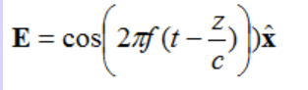

Consider this electric field that is travelling along the z axis and is pointed in x^ direction… Now if we consider a point, say origin..how is the electric field vector at origin varying with time?

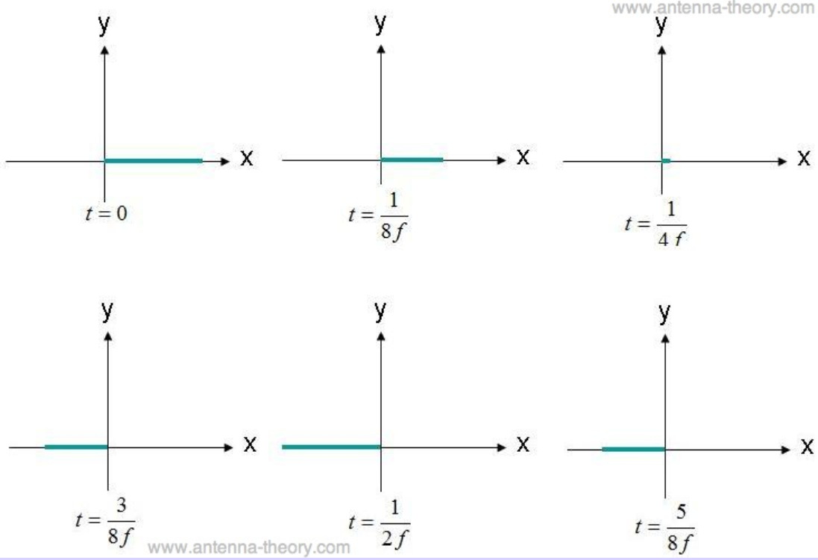

Something like this…. Here we see that the electric field is varying along the x axis which is a line so this is called a linearly polarized wave.

The wave doesn’t have to be polarized only along the x axis..it can be any line. In industry if the x axis is parallel to ground we call it horizontal polarization also.

Now consider the electric field

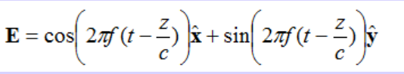

It varies at the origin something like

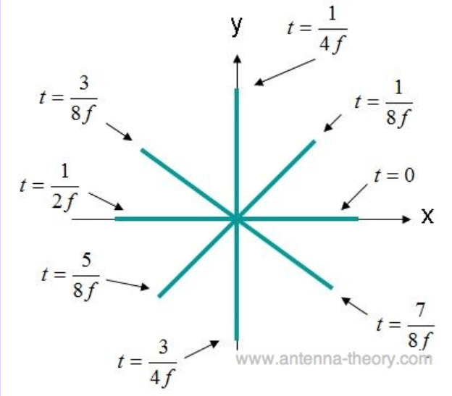

Hence we see that it is circularly polarized..

Similarly we have elliptically polarized waves where the ratio of maximum amplitude to minimum amplitude is called axial ratio…Circularly polarized is elliptically with axial ratio 1 and linearly polarized is elliptical with axial ratio infinity.

If the wave is turning counter clockwise it is called right hand elliptically polarized..and turning clockwise is called left hand elliptically polarized.

Now let's get to actual antenna polarization,

Antenna Polarization - It is the polarization of the radiated fields produced by an antenna in the far field. This is a very important concept for antenna to antenna communication.. The closer the polarization of transmitting and receiving antennas are, the better the communication. In general, for two linearly polarized antennas with angle phi between them, the power loss factor is



Therefore a horizontally polarized antenna wouldn’t work with a vertically polarized antenna..

<https://www.maartenbaert.be/quadcopters/antennas/polarization/> - refer to this for videos on how the wave will look for intuition.

Now let us look at some interesting cases..what happens if we use a linear antenna with a circularly polarized antenna? - The power received is halved. The reason being that the linear antenna receives all the components of the waves in its direction and rejects the other half.

And what happens if we use 2 circularly polarized antennas, one of RHCP and other being LHCP?

There is no transmission at all!!!(WHY???????)

Circularly Polarized antennas are most famous for two main reasons -

1. Orientation does not matter. Even if you turn one of the antennae by 90 degrees it'll work just fine.
2. They can reduce multipath interference. (When there are multiple paths from transmitter to receiver that may have a phase difference and hence cause destructive interference)

When RHCP bounces of a surface perpendicularly , it is converted to LHCP and the receiving antenna will just ignore it which reduces multipath..in reality it doesn't always bounce perpendicularly so there is a phase difference generated and not complete LHCP but that’s is enough to reduce its effects but you will get an elliptically polarized wave due to the interference.

Effective area/aperture

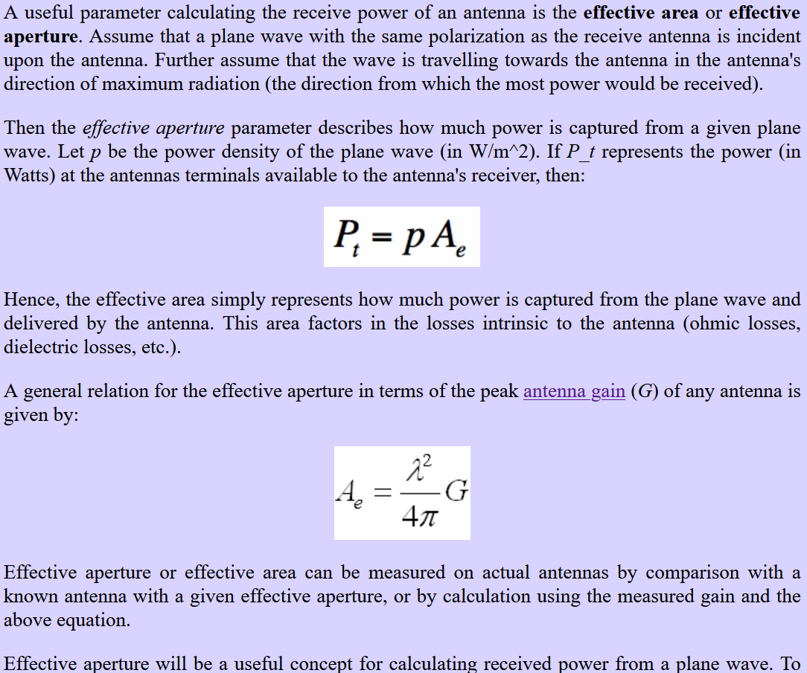

Friis equation

<https://www.antenna-theory.com/basics/friis.php> - Amazing webpage..read directly from it

Antenna Temperature

**Antenna Temperature** (antenna temperature) is a parameter that describes how much noise an antenna produces in a given environment. Also sometimes called antenna noise temperature…to define the environment, we define the temperature gradient T(theta,phi).

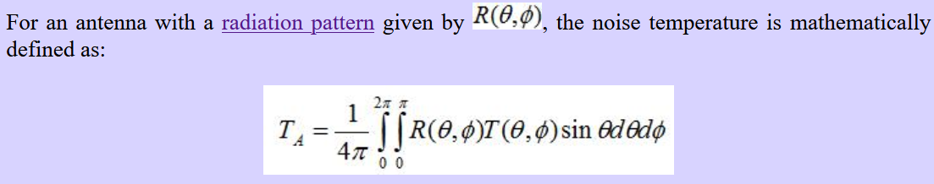

Therefore, an isotropic antenna has a noise temperature as the average of all the temperatures around it and for a perfectly directional antenna it will depend only on the temperature of the direction in which it is “looking”.

Data sheets for many antennas specify the ratio of gain to antenna temperature given as G/T with units dB/K.

Many RF engineers like to use the term noise figure or NF which is the ratio of input SNR to output SNR. It's not really related to antenna temperature.

Balun

It comes from “balanced to unbalanced”. If we learn by an example, if a coaxial cable carrying unbalanced current is connected to a short dipole antenna that needs balanced current, we might have problems. The reason being. One half of the dipole connected to the inner conductor will get all the current but the end connected to the outer layer will get the current minus the current that will flow backwards along the outside of the outer layer. To remove this backward flowing current we use balun techniques like bazooka balun etc.

Decibels - dB - to show gain

dBm - decibel milliwatt - to show power

dBi - to show gain relative to an isotropic antenna

dBd - to show gain relative to a half wave dipole antenna.

Smith Chart

<https://www.antenna-theory.com/tutorial/smith/chart.php>

Smith charts are used for impedance matching. It is a plot consisting of points corresponding to the complex reflection coefficient with respect to ZL and ZO. The closer the point is to the center of the chart, the better the impedance match and less reflected power so it is ideal. Network analyzers use this technique. The outer boundary of smith chart corresponds to a VSWR of infinity.

Types of Antennas

Short Dipole Antenna

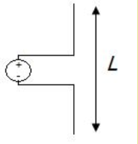

Simplest Antenna.. Open circuit but current flows because it is an AC voltage given.

<https://physics.stackexchange.com/questions/286805/how-can-current-flow-through-an-open-wire-like-a-dipole-antenna>

Length of antenna is less than a tenth of the wavelength. They are omni-directional with half power beam width of 90 degrees(45 on each side). Skin effect plays a big role at high frequencies with transmission loss becoming even bigger than radiation loss at high frequencies. Bandwidth is hard to define because input impedance varies a lot with small change in frequency. Therefore it is usually used in narrowband applications.

Gives somewhere around the lowest directivity you can realize in real life.

Dipole Antenna

Same as a short dipole but not short.

Helps achieve better directivity.

Radiation pattern doesn’t depend on azimuth so it is omni-directional.

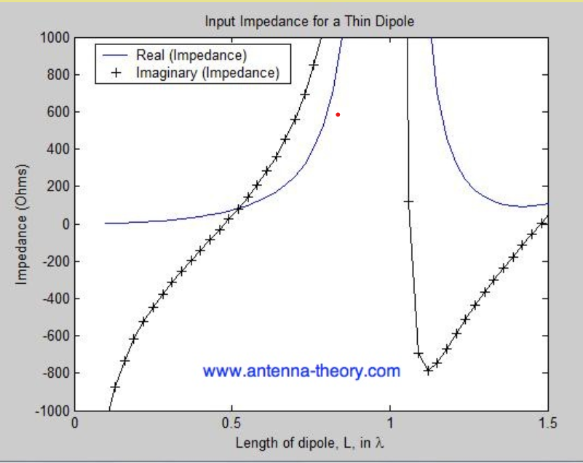

The reactance becomes zero at slightly less than 0.5 lambda. This is resonant point.

When length of antenna is equal to integer multiples of wavelength of signal, impedance goes to infinity because current becomes zero at the tips.

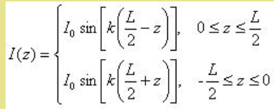

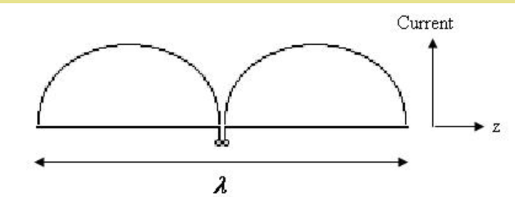

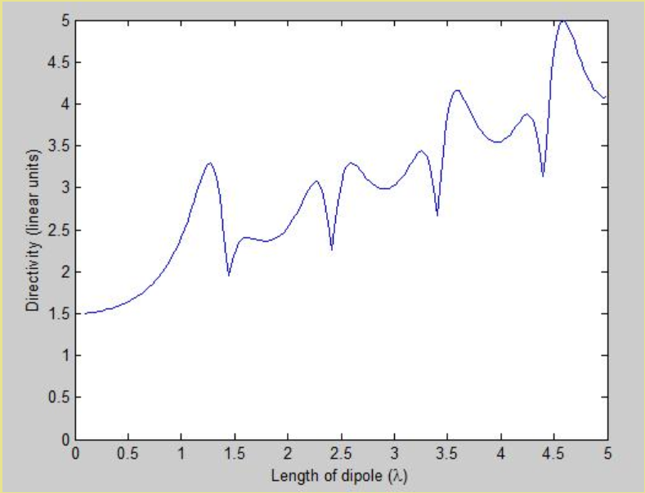

Directivity increases till about 1.25lambda and then increases but not monotonously.

Half-Wave Dipole

It’s a normal dipole antenna with length equal to half the wavelength (quarter on each side). It is quite famous. Makers tend to get it somewhere closer to 0.48lambda because impedance reactance becomes zero at this point making it better to use in radios etc.

Broadband Dipole Antenna

* A standard rule of thumb in antenna design is: an antenna can be made more broadband by increasing the volume it occupies.
* Hence, adipole antenna can be made more broadband by increasing the radius *A* of the dipole. These antennas are also known as **wideband dipoles**.
* 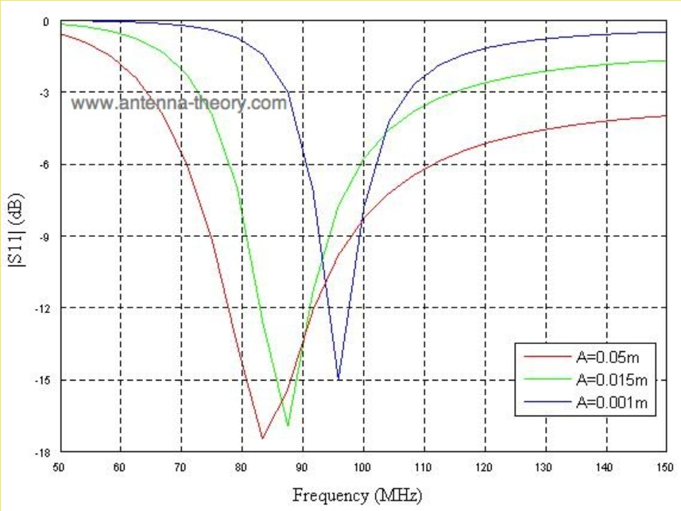

Monopole Antenna

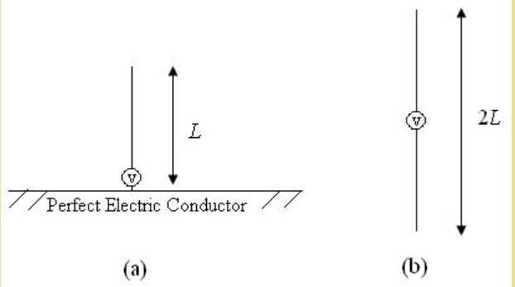

* The fields above the ground plane can be found by using the equivalent source (antenna) in free space as shown in Figure 1(b).
* This is simply a dipole antenna of twice the length. The fields above the ground plane in Figure 1(a) are identical to the fields in Figure 1(b). The monopole antenna fields below the ground plane in Figure 1(a) are zero.
* The only change that needs to be noted is that the impedance of a monopole antenna is one half of that of a full dipole antenna.
* The [impedance](http://www.antenna-theory.com/basics/impedance.php) of a monopole antenna is minimally affected by a finite-sized ground plane for ground planes of at least a few wavelengths in size around the monopole but the resulting radiation pattern radiates in a "skewed" direction, away from the horizontal plane.

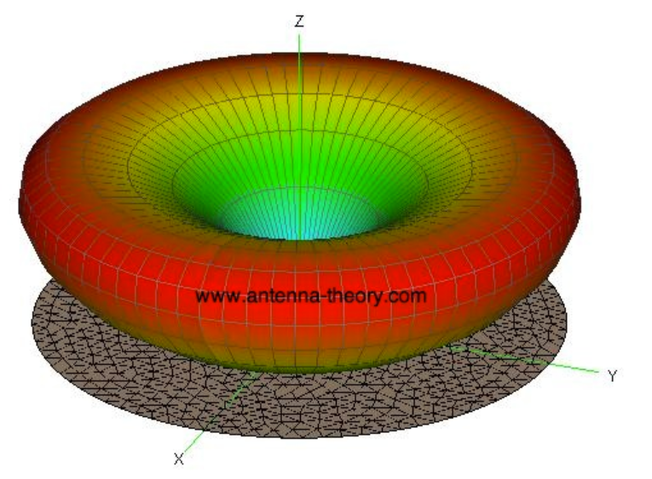

Helical Antenna

* The most popular helical antenna (helix) is a travelling wave antenna in the shape of a corkscrew that produces radiation along the axis of the helix antenna. These helix antennas are referred to as axial-mode helical antennas.
* The benefits of this helix antenna is it has a wide bandwidth, is easily constructed, has a real input impedance, and can producecircularly polarized fields.
* 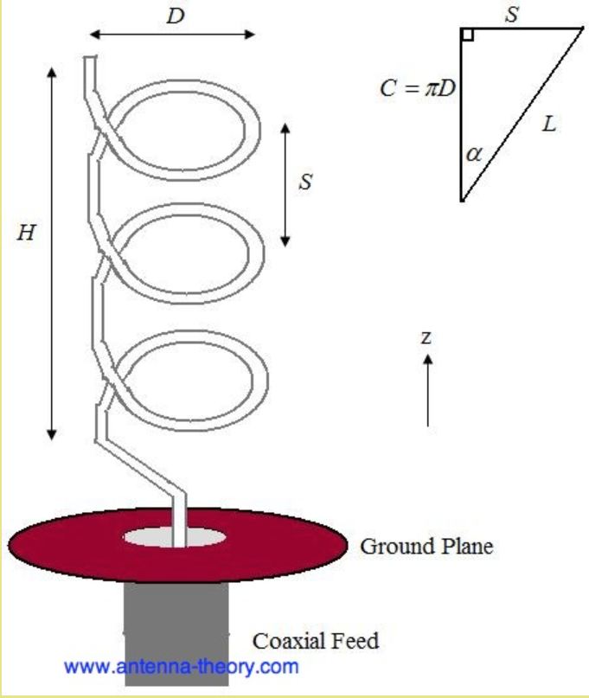
* The antenna in Figure 1 is a left handed helix antenna, because if you curl your fingers on your left hand around the helix your thumb would point up (also, the waves emitted from this helix antenna are Left Hand Circularly Polarized)
* The helix antenna functions well for pitch angles between 12 and 14 degrees. Typically, the pitch angle is taken as 13 degrees. Where pitch angle is tan inverse of ratio of vertical separation and circumference.
* The helix antenna is a **traveling wave** antenna, which means the current travels along the antenna and the phase varies continuously

Spiral Antennas

* **Spiral antennas** belong to the class of "frequency independent" antennas; these antennas are characterized as having a very large [bandwidth](http://www.antenna-theory.com/basics/bandwidth.php).
* Spiral antennas are usually [circularly polarized](http://www.antenna-theory.com/basics/polarization.php#polarization). The spiral antenna's [radiation pattern](http://www.antenna-theory.com/basics/radPattern.html) typically has a peak radiation direction perpendicular to the plane of the spiral (broadside radiation).
* Spiral antennas are widely used in the defense industry for sensing applications, where very wideband antennas that do not take up much space are needed.
* Some of the important parameters of spiral antennas are:

Total Length of the Spiral, or the outer radius-This determines the lowest frequency of operation for the spiral antenna. The lowest operating frequency of the spiral antenna is commonly approximated to occur when the wavelength is equal to the circumference of the spiral

The Flare Rate (a) - The rate at which the spiral grows with angle is the flare rate. If *a* is too small, the spiral is tightly wrapped around itself. In this case, it will behave more like a capacitor, with closely coupled conductors, giving poor radiation. If the flare rate is too large, the spiral acts more like a dipole as it doesn't wrap around itself.

Feed Structure - The feed must be controlled with abalun so that the spiral has balanced currents on either arm.

Number of Turns (N) - The number of turns of the spiral is also a design parameter. Experimentally, it is found that spirals should have at least one-half turn.

Corner Reflector Antenna - To increase thedirectivity of an antenna, a fairly intuitive solution is to use a reflector.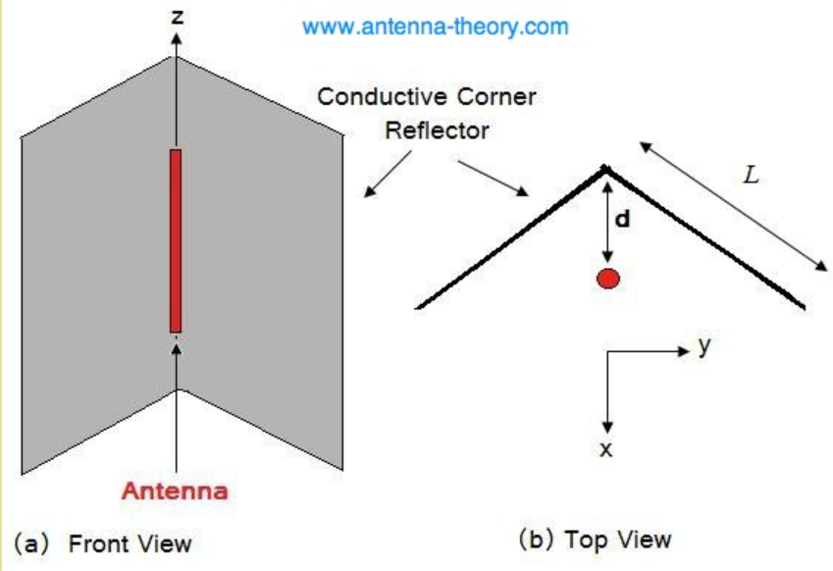

Parabolic Dish reflector

* The most well-known reflector antenna is the **parabolic reflector antenna**, commonly known as a **satellite dish antenna**.
* Parabolic reflectors typically have a very highgain (30-40 dB is common) and lowcross polarization. They also have a reasonable bandwidth, with thefractional bandwidth being at least 5% on commercially available models, and can be very wideband in the case of huge dishes.
* All rays emanating from the focal point (the source or feed antenna) will be reflected towards the same direction.
* The distance each ray travels from the focal point to the reflector and then to the focal plane is constant.

Work on Ansys HFSS -

http://anlage.umd.edu/HFSSv10UserGuide.pdf

Double on the thing in the left panel to go to its command window.

Validation check and analysis options are under HFSS.

A "frequency sweep" is simply **calculating the response of the antenna over a range of frequencies**. This would let you, for example, plot the input impedance as a function of frequency, or S11 as a function of frequency

Types of frequency sweeps :

1. **Discrete Sweep :** The discrete sweep is the most accurate as it resolves the problem at each frequency point in your whole frequency range. However, it is the slowest and the adaptive frequency should be set at the higher limit of your bandwidth or at the frequency where the wavelength is smallest.
2. **Fast Sweep :** The fast sweep requires less simulation time than the discrete sweep but at the expense of a limited frequency bandwidth range and reduced accuracy. The adaptive frequency should be set within the center of your frequency bandwidth and should coincide within the pass-band of your structure. if your adaptive frequency is 10 GHz, your frequency sweep can go from 1 GHz to 20 GHz. We generally tend to use this sweep mostly.
3. **Interpolating Sweep :** The interpolating sweep is the fastest, but the least accurate sweep. In addition, the field data cannot be saved for the frequency range and therefore has limited post processing attributes.

What is adaptive meshing ? - Ansys HFSS creating a conformal, non-homogeneous

mesh to describe the modeled geometry. This mesh is solved for electric fields, and Ansys HFSS determines

where the solved fields have errors due to the mesh’s failure to capture field gradients accurately. The mesh is

automatically refined in those locations, and the new mesh is solved. This adaptive process continues until a

specific output quantity, usually based on the S-parameters, changes less than a user-specified convergence

criteria between two consecutive adaptive passes.

Coaxial Cables

* Very famous type of transmission line. It consists of a solid cylindrical conductor surrounded by a dielectric followed by an outer conducting layer.
* The dielectric used is usually plastic like teflon but we can use air or some other gas while holding the center conductor in place using non conducting spacers.
* Outer conductor is usually a braid or shield of wires. A plastic sheath insulates this layer.
* The major benefit of coaxial cable is that it is completely shielded so that external noise has little or no effect on it.
* Coaxial cables are unbalanced lines; the current in the center conductor is referenced to the braid, which is connected to ground.
* Coaxial cables typically have a lower impedance compared to balanced lines and dipole antennas. In this case, a balun (balanced to unbalanced) transformer is often used to match them.

Simulating coaxial cable on ansys HFSS

<https://www.youtube.com/watch?v=w9SA9LjRuPA>

Used wave port to simulate excitation between the two conducting layers.

To remove overlap between 2 objects like 2 concentric cylinders , hold control and select both objects from the left window. After this is finished, go to modeler and select boolean, choose subtract.

To assign excitation to the area in between , right click anywhere on the field, select face selection, select the area between cylinders and then go to assign excitation.

Most common impedances of coaxial cables are 75 ohm and 50 ohm.

Yagi Antenna

https://www.electronics-notes.com/articles/antennas-propagation/yagi-uda-antenna-aerial/theory.php

* Simple to construct, has a high gain, usually greater than 10 dB.
* Typically operate between 3 MHz and 3GHz.
* Bandwidth is typically small, of the order of a few percent from center frequency.
* 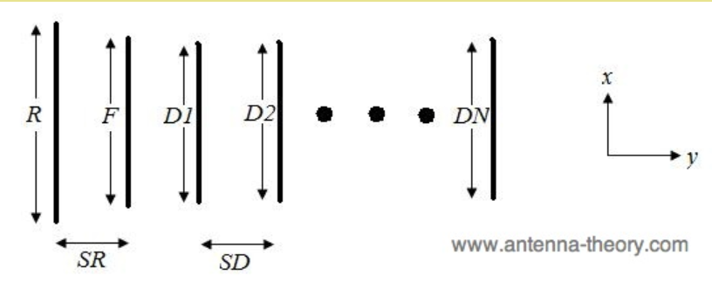
* F is the ‘feed’ or ‘driven’ element, typically a dipole or folded dipole. It is the only structure that is actually excited by a voltage source or current. It is usually the second element from the end. Its length is varied for impedance matching in the presence of parasitic elements.Its length is typically 0.45-0.48 of wavelength.
* All the other elements are parasitic. They either reflect or direct waves.
* The leftmost element is called the reflector element.
* The length of this element is given as *R* and the distance between the feed and the reflector is *SR*. The reflector element is typically slightly longer than the feed element. There is typically only one reflector; adding more reflectors improves performance very slightly. This element is important in determining the [front-to-back ratio](http://www.antenna-theory.com/definitions/fronttobackratio.php)(ratio of gain in maximum power direction to gain 180 degrees opposite) of the antenna.
* If the parasitic element is made inductive it is found that the induced currents are in such a phase that they reflect the power away from the parasitic element. This causes the RF antenna to radiate more power in the opposite direction to this form of parasitic element. An element that does this is called a reflector.
* The element can be made inductive by tuning it below resonance. This can be done by physically adding some inductance in the form of a coil, or more commonly by making it longer than the resonant length.
* Generally it is made about 5% longer than the driven element as this saves cost and keeps the element mechanically as one piece which makes it cheaper and stronger.
* ***Capacitive:*** If the parasitic element is made capacitive it will be found that the induced currents are in such a phase that they direct the power radiated by the whole antenna in the direction of the parasitic element.
* An element which does this is called a director. It can be made capacitive tuning it above resonance. This can be done by physically adding some capacitance to the element in the form of a capacitor, or more commonly by making it about 5% shorter than the driven element.
* It is found that the addition of further directors increases the directivity of the antenna, increasing the gain and reducing the beamwidth. The length of successive directors is reduced slightly.
* Boom is the long element that the directors, reflectors and feed elements are physically attached to, and dictates the length of the antenna.
* By symmetry: assuming you excite the "left and right" halves of the driving dipole with exactly opposing voltages, everything should be symmetrical across the plane through the middle of that dipole.
* Hence, if you approach that plane from left and right, you should see the same voltage, at any time. If two points have exactly the same potential, no current will flow. That's why Yagis work even if their elements are non-perfectly isolated from a metal boom.
* We can also use a non-conductive boom.
* **A cross yagi is nothing but two normal Yagi Uda antennas mounted on the same boom, rotated 90 degrees in position**

<https://ham.stackexchange.com/questions/6014/conductive-boom-vs-non-conductive-boom-whats-the-difference-on-a-yagi>

<https://www.elprocus.com/design-of-yagi-uda-antenna/>

<https://duo.com/labs/tech-notes/the-yagi-uda-antenna-an-illustrated-primer#section3>

Design standards of yagi-uda

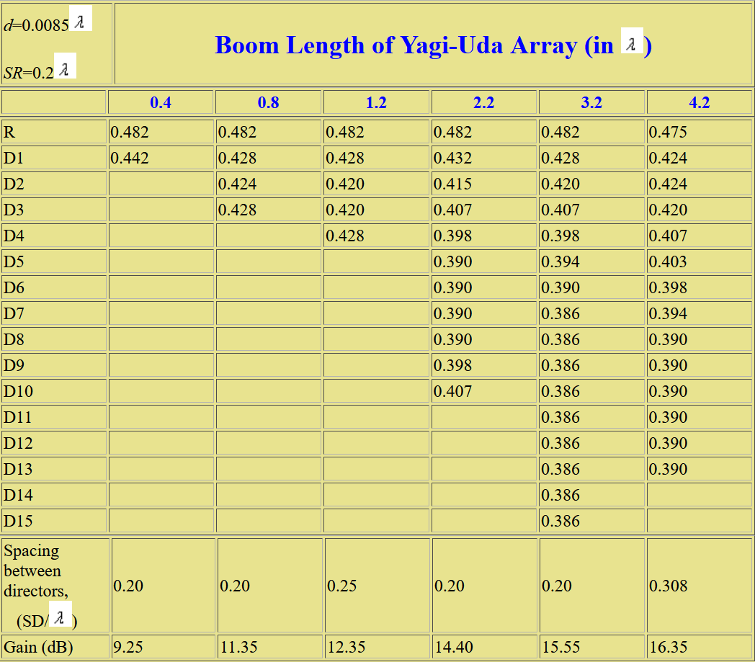

Let frequency be 437 MHz.

So lambda = 686.499 mm

d = 5.835mm

SR = 137.299 mm

Boom length = 0.8*lambda = 549.1992 mm

R = 0.482*lambda = 330.892mm

D1 = 0.428*lambda = 293.822mm

D2 = 0.424*lambda = 291.076 mm

D3 = 0.428*lambda = 293.822mm

SD = 0.2*lambda = 137.299mm

We will use a 0.45*lambda dipole as feed element.